**ERIC AGYEMANG**

**MAT 458-HOMEWORK 1**

**Due: 02/05/2020**

**Problem # 1**

**A1)** Set up appropriate hypotheses for **H0** and **H1 are given by**

***H0* : = 225 vs *H1*: 225**

**A2) SAS Code:**

**/*Problem 1*/**

data elecinstruments;

input hours @@;

cards;

159 280 101 212

224 379 179 264

222 362 168 250

149 260 485 170

;

run;

/*Part A2*/

proc univariate data=elecinstruments plot normal;

var hours;

run;

**SAS Output**

**The UNIVARIATE Procedure**

**Variable: hours**

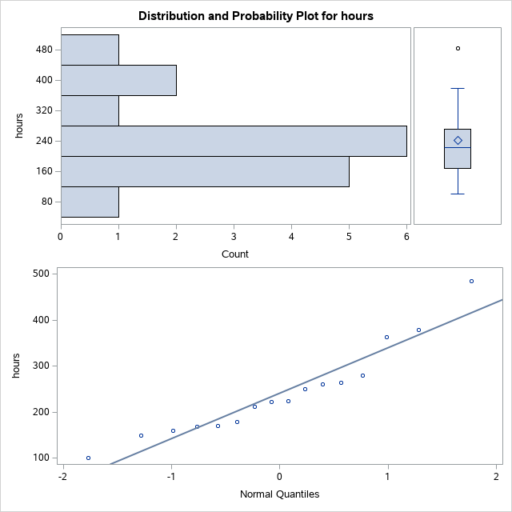

**B1) The output from (A2) to be used to get the sample mean and standard deviation is:**

**The UNIVARIATE Procedure**

**Variable: hours**

| **Moments** | | | |
| --- | --- | --- | --- |
| **N** | 16 | **Sum Weights** | 16 |
| **Mean** | 241.5 | **Sum Observations** | 3864 |
| **Std Deviation** | 98.7258831 | **Variance** | 9746.8 |
| **Skewness** | 1.08401096 | **Kurtosis** | 1.18606666 |
| **Uncorrected SS** | 1079358 | **Corrected SS** | 146202 |
| **Coeff Variation** | 40.8802829 | **Std Error Mean** | 24.6814708 |

| **Basic Statistical Measures** | | | |
| --- | --- | --- | --- |
| **Location** | | **Variability** | |
| **Mean** | 241.5000 | **Std Deviation** | 98.72588 |
| **Median** | 223.0000 | **Variance** | 9747 |
| **Mode** | . | **Range** | 384.00000 |
|  |  | **Interquartile Range** | 103.00000 |

Here $, \overline{y}$**= 241.50** which is the sample mean and ***S* =**  **98.72588 $≈$ 98.73** which is the standard deviation.

The test statistics is $T= \frac{\overline{y}-µ_{0}}{s/{\sqrt{n}}}$ **= $\frac{241.5-225}{ {98.73}/{\sqrt{16}}}$** = **0.668 $≈0.67$**

**B2)** We define the variable $DIFF=y-225$

* E[DIFF] = E [y – 225] = E [y] – 225 = 241.5 – 225 = **16.5**
* Var[DIFF] = Var [y – 225] = Var [y] = **9746.8**

So, Sd [DIFF] = $\sqrt{Var\left[DIFF\right]} = \sqrt{9746.8 }=98.72588$

* And, SE [DIFF] = $\frac{Sd [DIFF]}{\sqrt{n}} = \frac{98.72588}{\sqrt{16}} =24.68147$

**SAS CODE THAT SUPPORT THE CALCULATIONS ABOVE.**

data elecinstrumentsDiff;

input hours @@;

diff = hours-225;

cards;

159 280 101 212

224 379 179 264

222 362 168 250

149 260 485 170

;

run;

proc univariate data=elecinstrumentsDiff plot normal;

var diff;

run;

**SAS Output:**

**The UNIVARIATE Procedure**

**Variable: diff**

| **Moments** | | | |
| --- | --- | --- | --- |
| **N** | 16 | **Sum Weights** | 16 |
| **Mean** | 16.5 | **Sum Observations** | 264 |
| **Std Deviation** | 98.7258831 | **Variance** | 9746.8 |
| **Skewness** | 1.08401096 | **Kurtosis** | 1.18606666 |
| **Uncorrected SS** | 150558 | **Corrected SS** | 146202 |
| **Coeff Variation** | 598.338686 | **Std Error Mean** | 24.6814708 |

| **Basic Statistical Measures** | | | |
| --- | --- | --- | --- |
| **Location** | | **Variability** | |
| **Mean** | 16.50000 | **Std Deviation** | 98.72588 |
| **Median** | -2.00000 | **Variance** | 9747 |
| **Mode** | . | **Range** | 384.00000 |
|  |  | **Interquartile Range** | 103.00000 |

**C)** Run PROC Means with options Mean Var Stderr T PRT in the DIFF in (B2)

**SAS Code:**

data elecinstrumentsDiff;

input hours @@;

diff = hours-225;

cards;

159 280 101 212

224 379 179 264

222 362 168 250

149 260 485 170

;

run;

proc means data = elecinstrumentsDiff Mean Var Stderr T PRT;

var diff;

run;

**SAS OUTPUT:**

**The MEANS Procedure**

| **Analysis Variable: diff** | | | | |
| --- | --- | --- | --- | --- |
| **Mean** | **Variance** | **Std Error** | **t  Value** | **Pr > |t|** |
| 16.5000000 | 9746.80 | 24.6814708 | 0.67 | 0.5140 |

Here, t statistic value from **part B1** was **t=0.668** and that from **part C** is **0.67**. So, the t statistic values are similar.

**D)** Here, P value = 0.514/2 = 0.257

**Problem # 2**

1. The hypothesis required is given by**:**

**H0: μ1 - μ2 = 0 vs H1: μ1 - μ2  0**

1. The Hypothesis to be tested is: **H0: vs H1:**

**SAS Code:**

**/*Problem 2*/**

data machines;

input type ounces @@;

cards;

1 16.03 1 16.01 1 16.04 1 15.96 1 16.05 1 15.98 1 16.05 1 16.02 1 16.02 1 15.99

2 16.02 2 16.03 2 15.97 2 16.04 2 15.96 2 16.02 2 16.01 2 16.01 2 15.99 2 16.00

;

run;

proc ttest data= machines sides=2 alpha=0.05 h0=0;

class type;

var ounces;

run;

| **SAS Output:**  **Equality of Variances** | | | | |
| --- | --- | --- | --- | --- |
| **Method** | **Num DF** | **Den DF** | **F Value** | **Pr > F** |
| **Folded F** | 9 | 9 | 1.41 | 0.6168 |

The*P-Value* = 0.6168 at $α=0.05.$ Since the *P-value* is greater than the $α value,$ we fail to reject **H0** and conclude that the variances between the two machines are the same.

1. Test the hypothesis at $α=0.05.$

**SAS Output:**

| **Method** | **Variances** | **DF** | **t Value** | **Pr > |t|** |
| --- | --- | --- | --- | --- |
| **Pooled** | Equal | 18 | 0.80 | 0.4347 |
| **Satterthwaite** | Unequal | 17.493 | 0.80 | 0.4350 |

Because there is equal variances and we don’t assume to know the variances, the pooled variance t-test can be used. The *P-Value* = 0.4347 at $α=0.05 level.$ Since the P-value is greater than the $α value,$ we fail to reject **H0** and conclude that there is no difference in mean ounces that each machine puts in filling each bottle.

1. We compute the 95% CI for the difference in means (Using Pooled t).

**SAS Output:**

| **type** | **Method** | **Mean** | **95% CL Mean** | | **Std Dev** | **95% CL Std Dev** | |
| --- | --- | --- | --- | --- | --- | --- | --- |
| **1** |  | 16.0150 | 15.9933 | 16.0367 | 0.0303 | 0.0208 | 0.0553 |
| **2** |  | 16.0050 | 15.9868 | 16.0232 | 0.0255 | 0.0175 | 0.0465 |
| **Diff (1-2)** | Pooled | 0.0100 | -0.0163 | 0.0363 | 0.0280 | 0.0211 | 0.0414 |
| **Diff (1-2)** | Satterthwaite | 0.0100 | -0.0164 | 0.0364 |  |  |  |

The 95% Confidence interval for **μ1 - μ2** given by (-0.0163, 0.0211). This means the we are 95% confident that 0 will fall within this interval which indicates that there is no difference between the average number of ounces for the two machines